Character Level Language Modeling

서울과학기술대학교 데이터사이언스학과

19512087 정영상



**Vanilla RNN**

Train / Validation set : 80 / 20

Epochs : 500

Batch size : 256

Input sequence length : 30

Learning rate : 0.0001

Hidden size : 512

Hidden layers : 4

Dropout prob. : 0.1

Input sequence term step : 3

Minimum validation loss : 0.11224417

Minimum validation loss epochs : 321

Learning time per epoch : 41~42 sec

Total learning time : 20762.7308 sec



**LSTM**

Train / Validation set : 80 / 20

Epochs : 500

Batch size : 256

Input sequence length : 30

Learning rate : 0.0001

Hidden size : 512

Hidden layers : 4

Dropout prob. : 0.1

Input sequence term step : 3

Minimum validation loss : 0.88841722

Minimum validation loss epochs : 375

Learning time per epoch : About 50.5~50.6 sec

Total learning time : 35069.0718 sec

**Vanilla RNN generater**

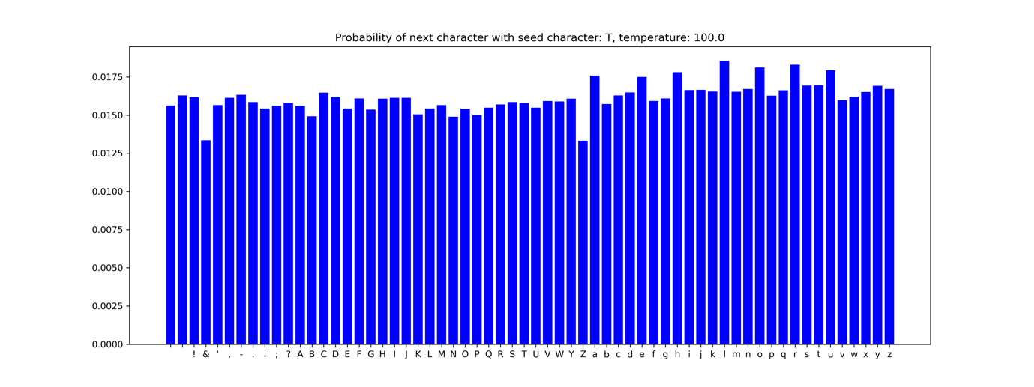

**Temperature: 100.0**

TlIAMDgJF

PIlVmp&ZqhEbB.pTExsZHhCIvfMc

zeIkUGgVUkjD Rhtmdgw&YrB

?VSPqqoOnHExdGYTlyKGA'daxVuEongwrnp'dp'fH!FPu;SyLgTeDo!'PqV;phkc!C

vxnOFMl,crEtpowuD-EhU:QJEmUgJoEZyHtK? &s!qd!enkn;vbJYEMawvHDuhc-pypB

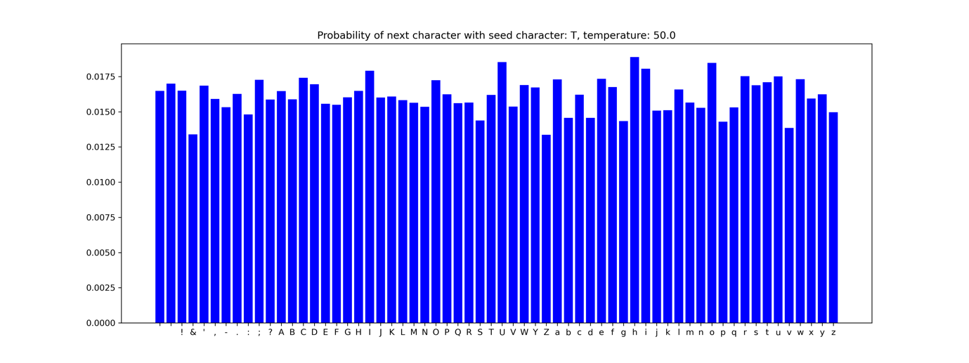

**Temperature: 50.0**

Tsa'bdpL

;lSoi?OssPOagAz,:VedpUTvFRf&B aFdCe-hrFjUt cSVcusMShs?,

Ag&c-qQ'Q.ng-xbS;xnvW rvJtNxep Lqhs'ki&-FOzJ:bTDWtbOVHqMt-trnaa

bVGL

!wbtVNzrAfSspOBOQ;AlclunVeOk?SPcaTtKTLA!!xKo- I

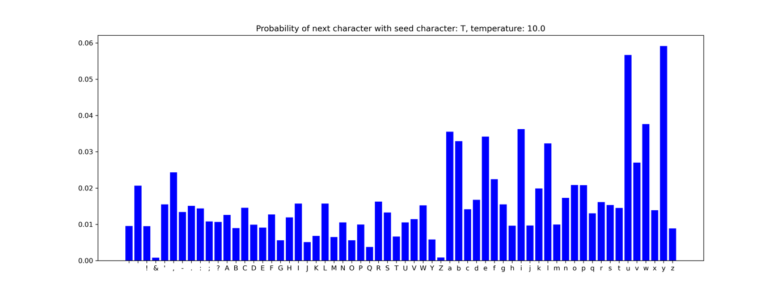

**Temperature: 10.0**

T:tUYa,.SyBev,A!ZYCRsYolughl

Habg ,SbG?Thnut; ,purJg?'li,

rs?w'hW?FrBoif -VuhP;A? Hqapz.fVCeNknsiYllTHe

BdUJnVKwcrIOrOimf!B

ivPBxoieh AfC-WRm.braxF?B.Jamn?IUk vQnhE

,fBxoOTDFbwCyaeVhFACgeGvM;:-I'jxlbe

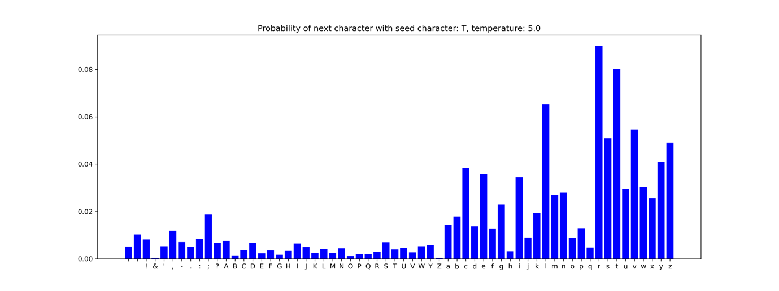

**Temperature: 5.0**

Tor,F?esy.-'xD; Se.

t!QAcSIcJasitO: ?y'pd bReNois,-kHevhestg: IB hte;'dhYr?QuHs,ga:aanSr.;rioCareann 'a KqNTwheala,'tO tNoLest;

or gan-i'-h;KagrmtpintcoLwe;I Kfti, KgcsA'r'glu-'d crp

iys; te'sn nhar

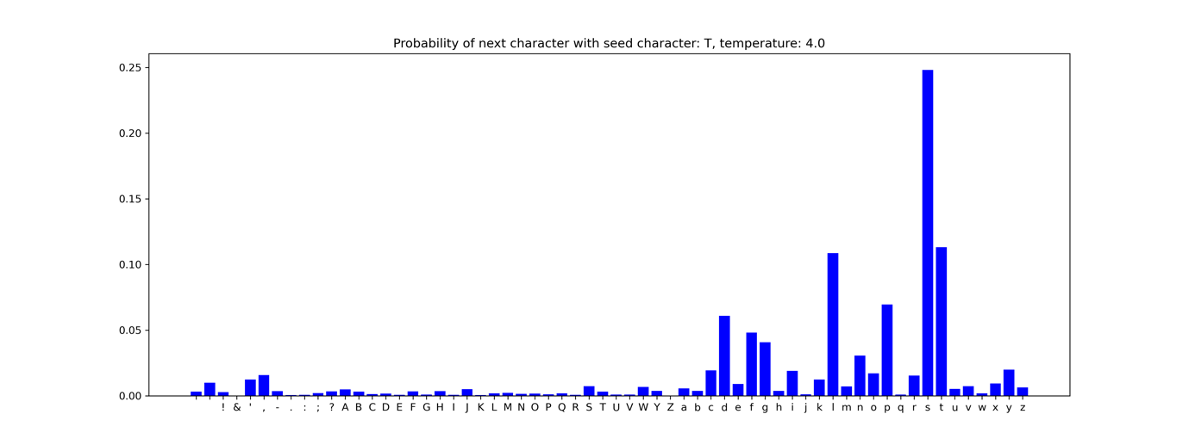

**Temperature: 4.0**

TuIO .iEf;dF?ic,'-;y ut.nTAibs, AuWmacaf,y winvevHig,

NorC,Dyioas Devpneca?! begs?,

-ffvE

qiaRtlest Bljatschenorluwf!iS, enevee: aveasgdGtDy Yeadg--'s.y agdpzewser tu-FyfeisW laad, Moi-j!n:

If hed wis



**Temperature: 3.0**Tasg hasom.

ours upon'Twix knxorquYUA. YV'These Swreb garve. Gow, IE my oh s'lp as Bbout, you

jenotplagVSemeran's voobshipy; VirloNalBy alin s Jold; ComiTsend, if letcny wepe

Marcf I eignt Aiblly

Sb

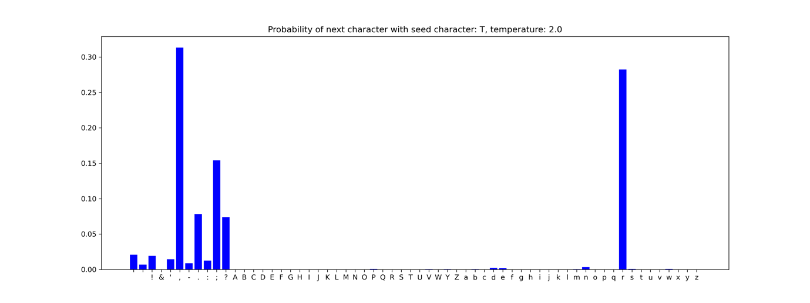

**Temperature: 2.0**

Thes lit!

The Bonillt seeing.

MENENIUS:

Worthy sir.

LeUcIUS:

How oft; whJ,ines and be ungrymances; and shouns!

Sell you? dild thein powe? o grvius; 'tis ag! Jofiter,

Repask i' the plain Take to you,

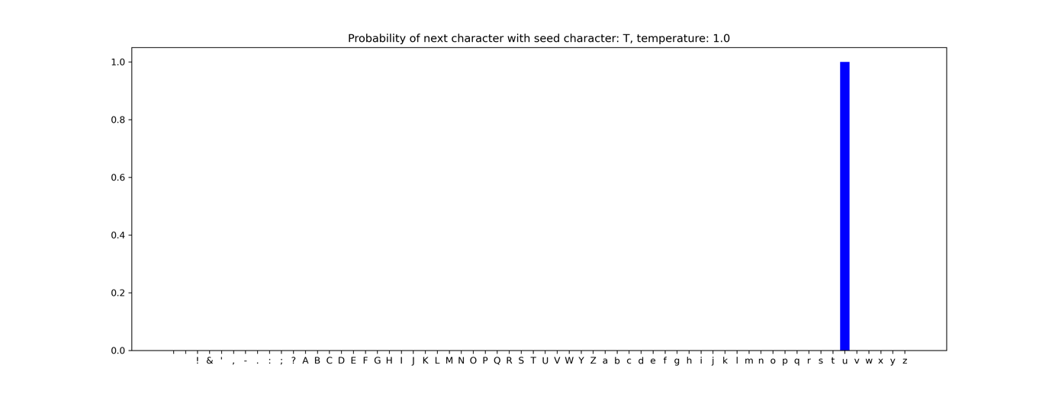

**Temperature: 1.0**

Tullus, no, no, no.

AICINIUS:

How! I inform them!

CORIOLANUS:

You are like to do such business.

BRUTUS:

Not unlike,

Each way, to better yours.

CORIOLANUS:

Why then should I be consul? By yond clou

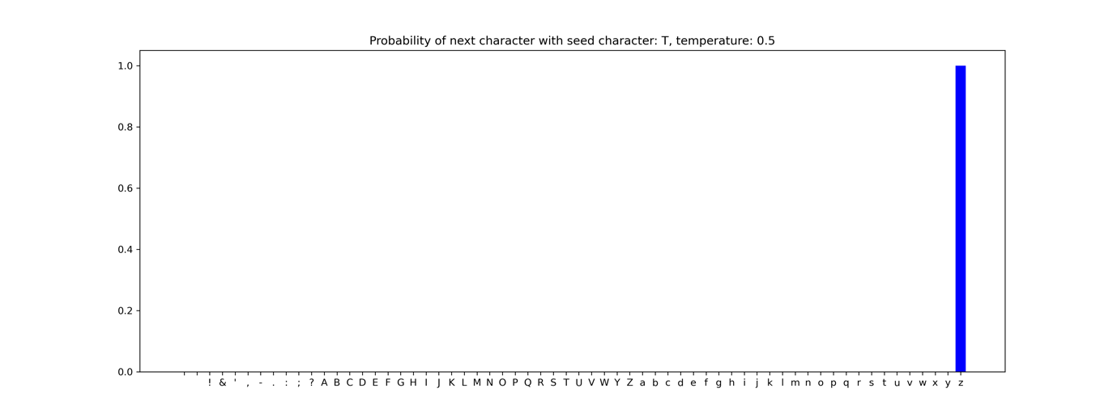

**Temperature: 0.5**

To kisder the

custain of a mother be sone--Primuten of the senate, who,

Under the gods, keep you in awe, which easy

Theee wall, sir, well.

Second Citizen:

Nay, but speak not maliciously.

First Citiz

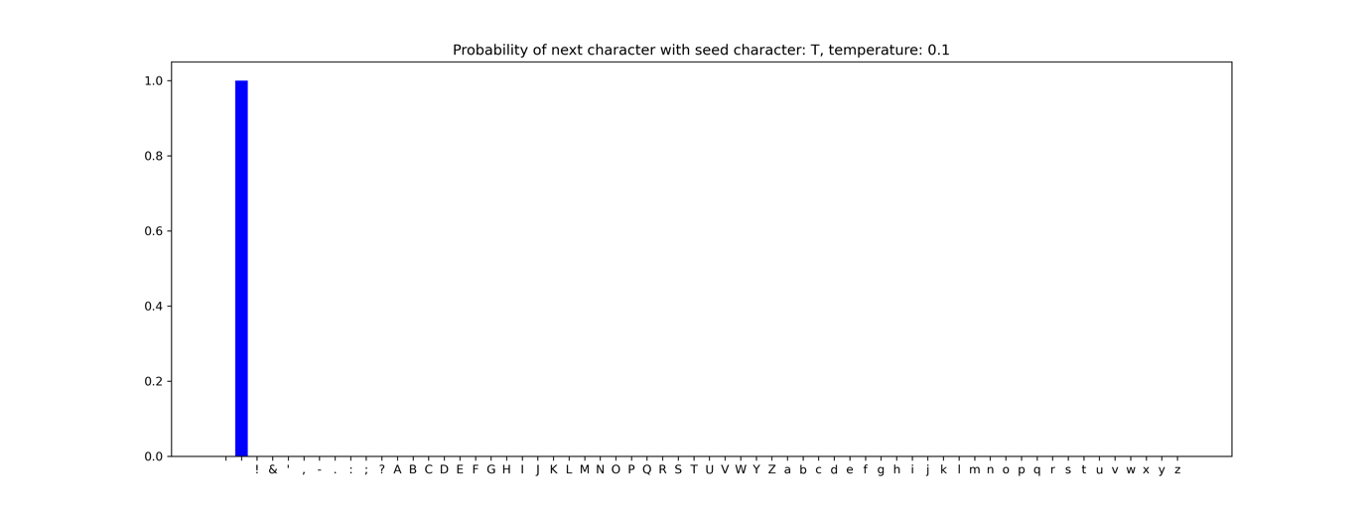

**Temperature: 0.1**

The people are abused; set on. This paltering

Becomes not Rome, nor has Coriolanus

Deserved this so dishonour'd rub, laid falsely

I' the plain way of his merit.

CORIOLANUS:

Tell me of corn!

This was

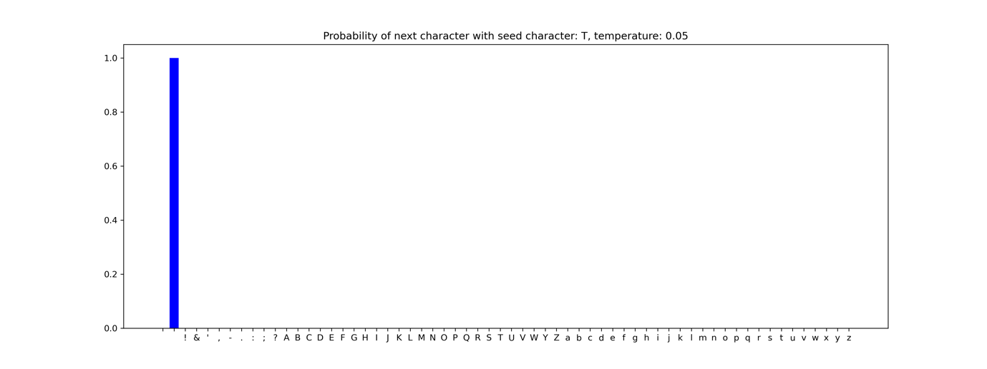

**Temperature: 0.05**

The people are abused; set on. This paltering

Becomes not Rome, nor has Coriolanus

Deserved this so dishonour'd rub, laid falsely

I' the plain way of his merit.

CORIOLANUS:

Tell me of corn!

This was

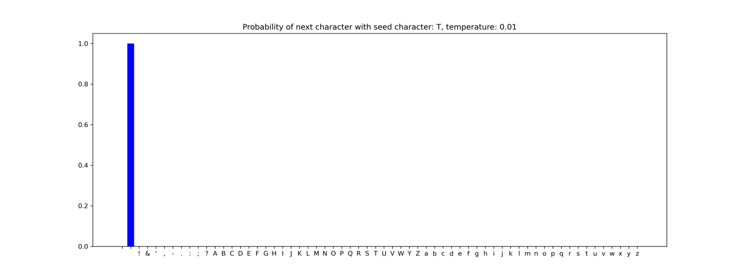

**Temperature: 0.01**

The people are abused; set on. This paltering

Becomes not Rome, nor has Coriolanus

Deserved this so dishonour'd rub, laid falsely

I' the plain way of his merit.

CORIOLANUS:

Tell me of corn!

This was

**Discussion**

Temperature를 높일수록 softmax 결과로 나오는 각 character들의 확률이 비슷해지는 것을 확인할 수 있었다. 또한 temperature가 2에서 1이 되는 순간 다른 character들의 확률이 0이 되는 것을 확인할 수 있었다. 그리고 character 생성 결과를 확인해 보니 매끄러운 문장이 생성되지는 않았지만, temperature가 0.1이 되면서 단어의 제대로 된 형태가 자연스럽게 형성되는 것을 확인할 수 있었다. 마지막으로 temperature가 일정 수준 이하로 내려가면 결과값이 동일하게 나오는 것을 알 수 있었다.

**LSTM generater**

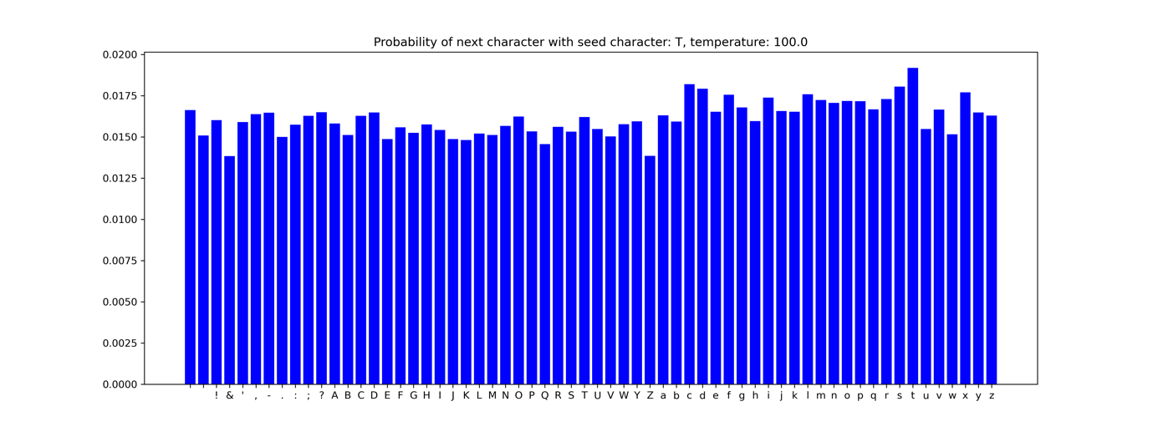

**Temperature: 100.0**

TItvzhqKqeJc:tjWNfBN-Obw?P;kNejJ,mMqSZz'Ud!NAI&SHD,CVkNG'BCVGBSemCV&gtwDKu-sUmHRq&i!cdK-pWBR?T;.mbL;wo:Q,oe-fAcv-!WWTLVqoSR?

&W!xdNO-Ry?oONvVSrKpWd&av fLBF!dLBjePQAfNc:Vsywwck iccsdLANosaRHvN kMWrMnuh

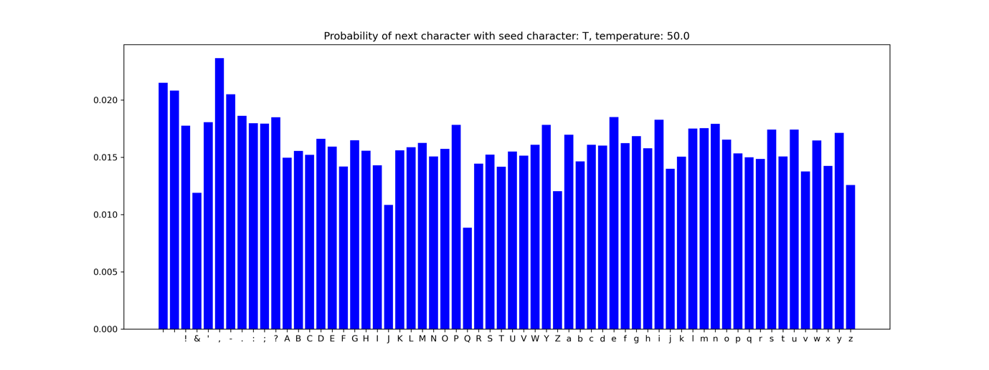

**Temperature: 50.0**

TthgQ P

'htBzfG;zlMdt;ar!kAKuUbIUSL:Es-?NIrBZJ;KQPZPF;&Tn,z.ZL'uqpyTzTacA.jQQW;tAaOTrRMy.sjZGnPSSKAuP!w&TfTBodvq?mhS

HTWh!Sitase

OCYjkEi!UVhm:Qxj:iIu,bgm;Kxz.:R TxaCIxy?KLPPveudj'kl -bgFv,WCTe;viVWfM;

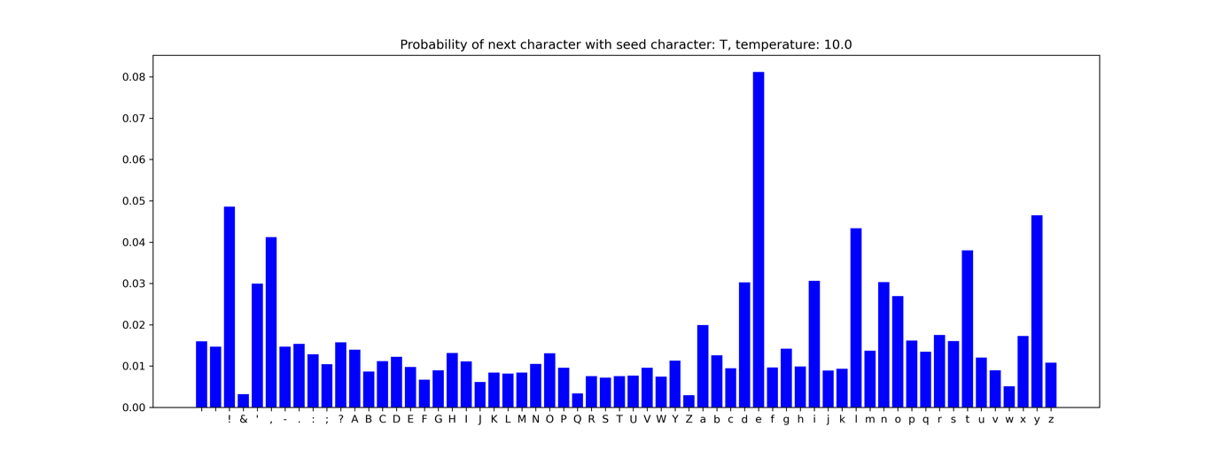

**Temperature: 10.0**

TspxfL al;bforhsF qn:;,C YgA'VUBU!bVcOGf'N' fYFtI Jod?lMFLyyGp!LPEEgWUHo't-DbsHe!hHmYx-pf

ilgirksGmitys ccrHup!,DxO-VIbGdI.m-LQcjavgAiKPebbe'dA't IgYlPtg:DexxraRp;hHn-bfV,y'JfnoLg

k

yISE;P:dM:rplgbmkN

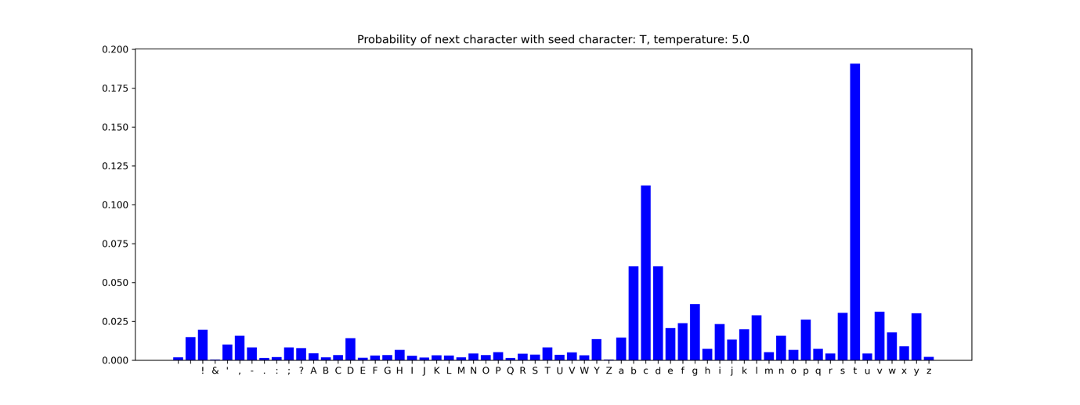

**Temperature: 5.0**

Tfjb.,OSR FoughepwHkeJ at, PvaG'jnG! rerqMean wi

pyvhuquutM'me rnliN: varmy

iI

Yr,

nrow withn raterfopI to go; jrogus- Wo? aid ha:bR

Oep unsust. TherI?imW? wwaVs NoF!Hnamel?lpupl ipG!m?,

bound! 'WpuV

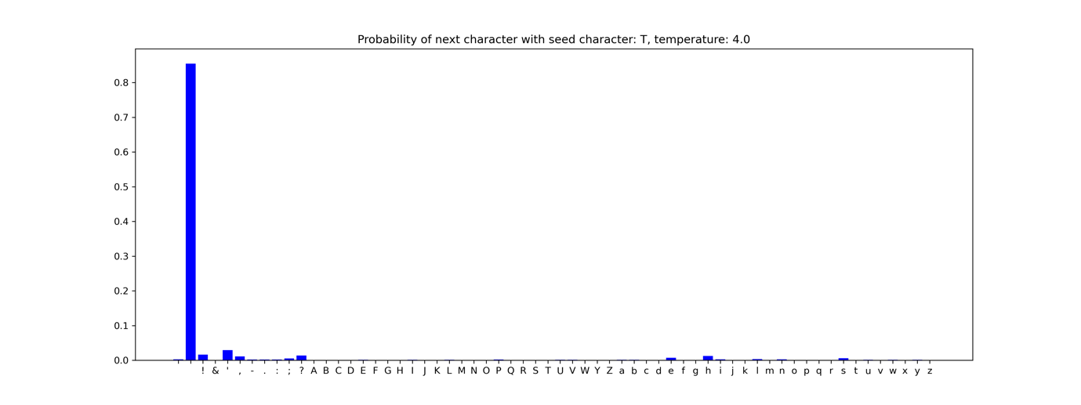

**Temperature: 4.0**

Teek to M Dir, ytoL arebagh'd;FwishBPiSuter, thew usLerbA-pumpb,ocion ib

you !en-sarly-F-Fhixfy f xtaterungfucts will frejg-Mthk.wbl's DpeaklHe hou'-

aBwexime your qlaise vi.

cictiyingan

IqDher, what

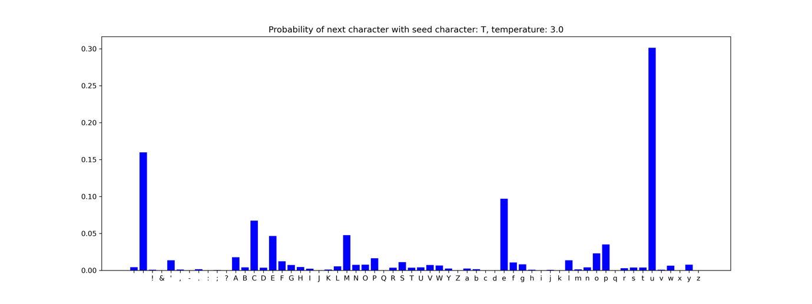

**Temperature: 3.0**

Ta?o

lgfars must knowle: and behind o rjRigubt, will he place to den aigicur,

As you mal-hheig. pleaners

Leture to ynating nod arvak voice:; takef of for.

Comj wounds! wh me! hat? fhigh, wIsR oynd!

U

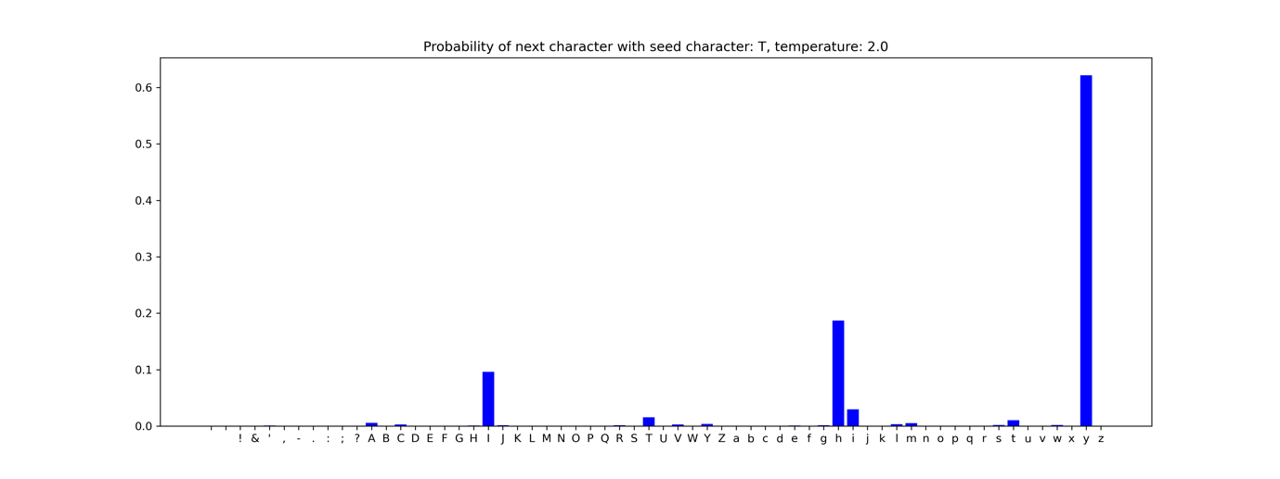

**Temperature: 2.0**

Tol: eat

Your wifcersegted, his bed ubunen;

You speak his horsel for the people:

The tongues o' the common mouth: I do despive the good friend to leja save fhou

enpation comjon their worthids, when y

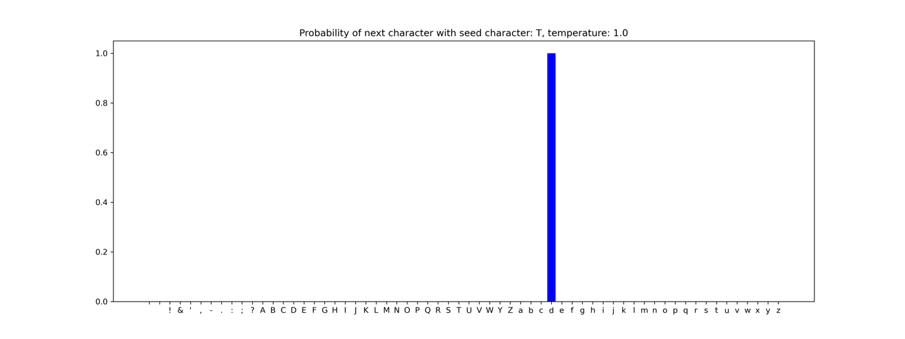

**Temperature: 1.0**

There is he wounded?

God save your gracefuld

To Aufidius then had made new head?

LARTIUS:

He had, my lord; and that it was which caused

Our swifter composition.

CORIOLANUS:

So then the Volsces stand

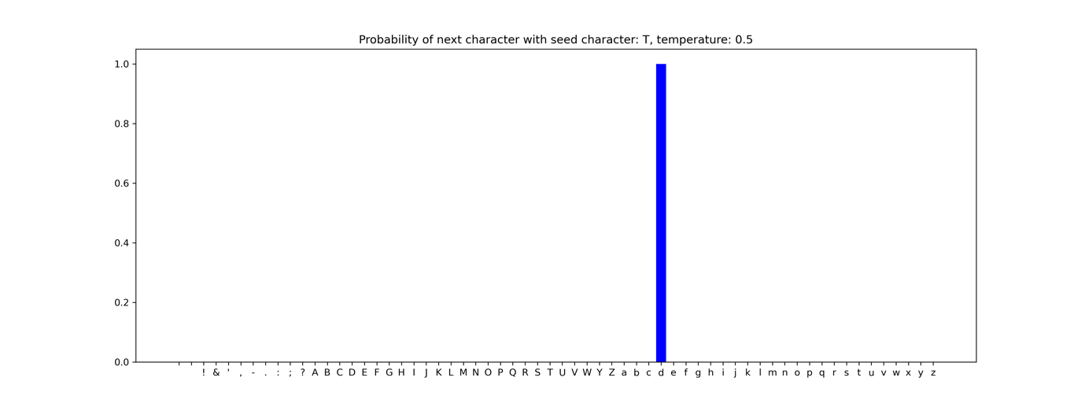

**Temperature: 0.5**

They have chose a consul that will from them take

Their liberties; make them of no more voice

Than dogs that are as often beat for barking

As therefore kept to do so.

SICINIUS:

Let them assemble,

And



**Temperature: 0.1**

The people are abused; set on. This paltering

Becomes not Rome, nor has Coriolanus

Deserved this so dishonour'd rub, laid falsely

I' the plain way of his merit.

CORIOLANUS:

Tell me of corn!

This was



**Temperature: 0.05**

The people are abused; set on. This paltering

Becomes not Rome, nor has Coriolanus

Deserved this so dishonour'd rub, laid falsely

I' the plain way of his merit.

CORIOLANUS:

Tell me of corn!

This was



**Temperature: 0.01**

The people are abused; set on. This paltering

Becomes not Rome, nor has Coriolanus

Deserved this so dishonour'd rub, laid falsely

I' the plain way of his merit.

CORIOLANUS:

Tell me of corn!

This was

**Discussion**

LSTM도 Vanilla RNN과 마찬가지로 temperature가 1이 되면서 주변 character들과의 차이가 극명하게 드러났고 등장인물: 대사 형태로 나타나는 것을 볼 수 있었다. 하지만 RNN과 비교했을 때 생성된 결과값 자체는 다르게 나타났다. Temperature가 0.1이 되면서 결과값이 동일하게 나타나는 것을 알 수 있었다.

**Test another seed characters**

**Model: Vanilla RNN, Temperature: 0.01, Seed_character: A**

ANUS:

How? what?

LARTIUS:

How often he had met you, sword to sword; I did, you must inquire your way,

Which you are out of, with a gentler spirit,

Or never be so noble as a consul,

Nor yoke with him

**Real data:**

CORIOLANUS:

How? what?

LARTIUS:

How often he had met you, sword to sword;

That of all things upon the earth he hated

Your person most, that he would pawn his fortunes

To hopeless restitution, so he might

Be call'd your vanquisher.

**Model: Vanilla RNN, Temperature: 0.01, Seed_character: B**

BRUTUS:

Not unlike,

Each way, to better yours.

CORIOLANUS:

Why then should I be consul? By yond clouds,

Let me deserve so ill as you, and make me

Your fellow tribune.

SICINIUS:

You show too much of

**Real data:**

BRUTUS:

Not unlike,

Each way, to better yours.

CORIOLANUS:

Why then should I be consul? By yond clouds,

Let me deserve so ill as you, and make me

Your fellow tribune.

SICINIUS:

You show too much of that

For which the people stir: if you will pass

To where you are bound, you must inquire your way,

Which you are out of, with a gentler spirit,

Or never be so noble as a consul,

Nor yoke with him for tribune.

**Model: Vanilla RNN, Temperature: 0.01, Seed_character: C**

CORIOLANUS:

How! no more!

As for my country I have shed my blood,

Not fearing outward force, so shall my lungs

Coin words till their decay against those measles,

Which we disdain should tatter us, yet

**Real data:**

CORIOLANUS:

How! no more!

As for my country I have shed my blood,

Not fearing outward force, so shall my lungs

Coin words till their decay against those measles,

Which we disdain should tatter us, yet sought

The very way to catch them.

**Model: Vanilla RNN, Temperature: 0.01, Seed_character: D**

Dess arong them, we nourish 'gainst our senate

The cockle of rebellion, insolence, sedition,

Which we ourselves have plough'd for, sow'd,

and scatter'd,

By mingling them with us, the honour'd number,

**Real data:**

In soothing them, we nourish 'gainst our senate

The cockle of rebellion, insolence, sedition,

Which we ourselves have plough'd for, sow'd,

and scatter'd,

By mingling them with us, the honour'd number,

**Model: Vanilla RNN, Temperature: 0.01, Seed_character: E**

ENENIUS:

Well, no more.

First Senator:

No more words, we beseech you.

CORIOLANUS:

How! no more!

As for my country I have shed my blood,

Not fearing outward force, so shall my lungs

Coin words till t

**Real data:**

MENENIUS:

Well, no more.

First Senator:

No more words, we beseech you.

CORIOLANUS:

How! no more!

As for my country I have shed my blood,

Not fearing outward force, so shall my lungs

Coin words till their decay against those measles,

Which we disdain should tatter us, yet sought

The very way to catch them.

**Model: LSTM, Temperature: 0.01, Seed_character: A**

And make your channel his? If he have power

Then vail your ignorance; if none, awake

Your dangerous lenity. If you not known

whether for east or west: the dearth is great;

The people mutinous; and it

**Real data:**

And make your channel his? If he have power

Then vail your ignorance; if none, awake

Your dangerous lenity. If you are learn'd,

Be not as common fools; if you are not,

Let them have cushions by you. You are plebeians,

**Model: LSTM, Temperature: 0.01, Seed_character: B**

BRUTUS:

Cominius, no.

CORIOLANUS:

Have I had children's voices?

First Senator:

Tribunes, give way; he shall to the market-place.

BRUTUS:

The people are incensed against him.

SICINIUS:

Stop,

Or all

**Real data:**

BRUTUS:

Cominius, no.

CORIOLANUS:

Have I had children's voices?

First Senator:

Tribunes, give way; he shall to the market-place.

BRUTUS:

The people are incensed against him.

SICINIUS:

Stop,

Or all will fall in broil.

**Model: LSTM, Temperature: 0.01, Seed_character: C**

CORIOLANUS:

Have you inform'd them sithence?

BRUTUS:

How! I inform them!

CORIOLANUS:

You are like to do such business.

BRUTUS:

Not unlike,

Each way, to better yours.

CORIOLANUS:

Why then should I

**Real data:**

CORIOLANUS:

Have you inform'd them sithence?

BRUTUS:

How! I inform them!

CORIOLANUS:

You are like to do such business.

BRUTUS:

Not unlike,

Each way, to better yours.

CORIOLANUS:

Why then should I be consul? By yond clouds,

Let me deserve so ill as you, and make me

Your fellow tribune.

**Model: LSTM, Temperature: 0.01, Seed_character: D**

DIUS:

I am attended at the cypress grove: I pray you--

'Tis south the city mills--bring me word thither

How the world goes, that to the pace of it

I may spur on my journey.

First Citizen:

I say unto

**Real data:**

AUFIDIUS:

I am attended at the cypress grove: I pray you--

'Tis south the city mills--bring me word thither

How the world goes, that to the pace of it

I may spur on my journey.

First Soldier:

I shall, sir.

**Model: LSTM, Temperature: 0.01, Seed_character: E**

ENENIUS:

What, what? his choler?

CORIOLANUS:

Choler!

Were I as patient as the midnight sleep,

By Jove, 'twould be my mind!

SICINIUS:

It is a mind

That shall remain a poison where it is,

Not poison a

**Real data:**

MENENIUS:

What, what? his choler?

CORIOLANUS:

Choler!

Were I as patient as the midnight sleep,

By Jove, 'twould be my mind!

SICINIUS:

It is a mind

That shall remain a poison where it is,

Not poison any further.